USER GUIDE

UPdate Physicians

September 2018

Version 1.02

Pharmacon ITC303/309 Group

Document Revisions

|  |  |  |
| --- | --- | --- |
| Date | Version Number | Document Changes |
| 31/08/2018 | 1.01 | Draft |
| 15/09/2018 | 1.02 | Initial |
|  |  |  |
|  |  |  |
|  |  |  |
|  |  |  |
|  |  |  |
|  |  |  |
|  |  |  |

Table of Contents

1 Introduction 4

1.1 Scope and Purpose 4

1.2 Process Overview 4

2 Update an Physician 5

2.1 Update Physician Record 5

2.1.1 Upload Physician record to Physician Details Form. 5

2.2 Change Details 5

2.2.1 Locate field needing amendment: 5

# Introduction

## Scope and Purpose

The purpose of this user guide is to provide instructions on how to update a physician that has loaded into the Physician Details Form through the search feature.

No other features of the Pharmacy Error Tracker (PET) application will be discussed in this user guide.

* To be able to use PET, the user will need basic knowledge of logging into an online application, completing an online form, and can use the search function of PET.
* This feature is only available to a user with administrator rights.
* This user guide will commence from the last step in User Guide – Search Physicians.

NOTE: The user must have a legitimate reason for amending/updating a physician record. For example, incorrect spelling, missed adding a comment, etc.

## Process Overview

The administrator will need to log into PET using their valid username and password.

* The Welcome Page will be presented on successful login.
* The administrator will need to follow the User Guide - Search Physicians to search for the required record.

# Update an Physician

User must have located the required record via Search Physicians.

*NOTE: ALL fields in the form can be updated to correct information/fields that contain mistakes. Care needs to be taken to ensure correct information is not changed accidentally*.

## Update Physician Record

User must have access to the application.

User must have a valid username and password with administration rights.

### Upload Physician record to Physician Details Form.

1. Select the record to be amended by clicking on the  to the right of the record.

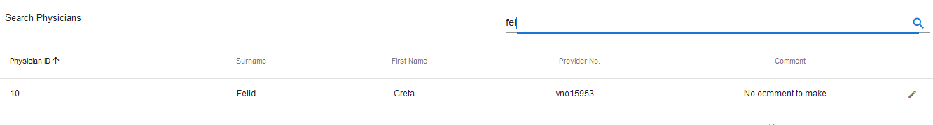

1. The record loads into the Physician Details Form

## Change Details

### Locate field needing amendment:

1. Locate the field containing incorrect information. Click in the field and amend the details as required  
   In the example above, the Surname and the Physician Comment have spelling errors.

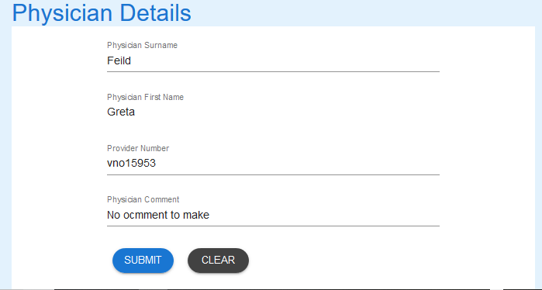

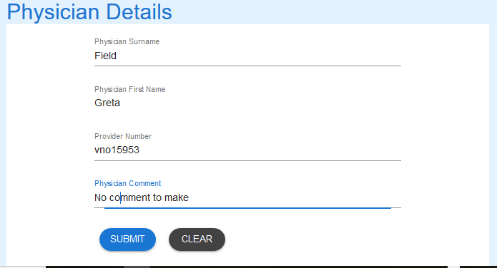

1. Select SUBMIT to update the record.



1. A successful update will receive the following message.



If you encounter issues not addressed by this user guide, please contact your account manager for additional support.